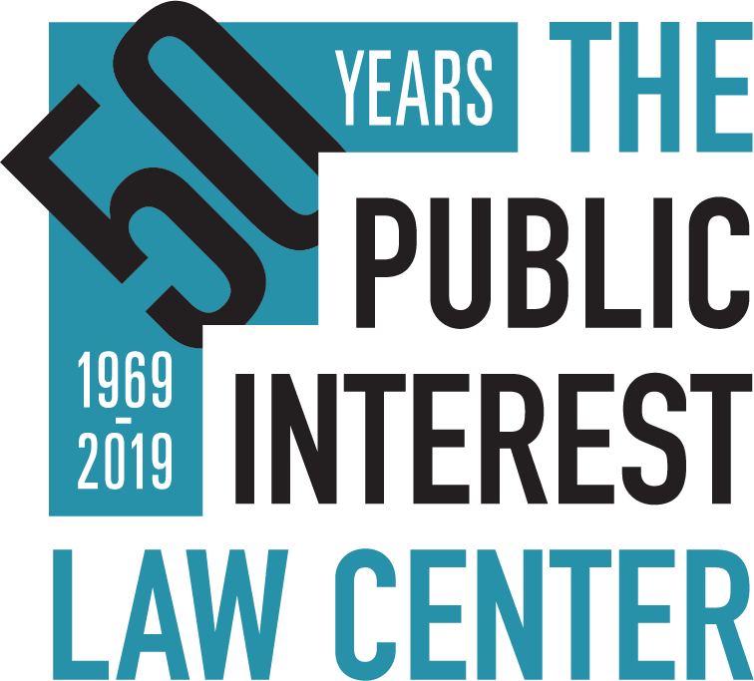

January 30, 2019

PUBLIC INTEREST LAW CENTER—Director of Development and Communications position available

The Public Interest Law Center is seeking applications for a Director of Development and Communications. The director is responsible for creating and successfully executing a comprehensive annual development plan and overseeing the organization’s communications efforts. The director takes the lead on securing funding from institutional sources, especially foundations and corporations, and supervises the development manager on individual giving. The director is also responsible for strengthening the organization’s visibility through improved media relations, events and marketing.

The director is part of the management team, reports to the executive director, and supervises the development manager and the communications associate. The individual works closely with the Board of Directors, and supports the board’s five-year financial plan and event board committees. The director works closely with the director of administration and contract bookkeeper in tracking revenue and grant expenses; the chief strategy officer in executing major initiatives; and staff

Specific responsibilities include:

Development

- Development plan: In advance of each fiscal year, work with management team and development team to create the annual development plan, including goals and strategies. Partner with management team to develop the contributed revenue and fundraising-related expenses for the annual organizational budget. Lead the full team in executing the development plan.
- Foundations: Manage the foundation funding process, including: cultivating relationships with foundation executives and their board members; designate cultivation assignments and deadlines for the executive director; work with the communications associate to identify new prospects; oversee work of external grant writer; draft applications as needed; request feedback from foundations on submitted grants; oversee preparation of reports; and, work with executive director, director of administration, and outside bookkeeper on grant budgeting and tracking.
- Corporations: Design and implement cultivation strategies to expand contributed revenue from law firms and businesses, including: supervise communications associate to identify prospects; draft content for corporate solicitation letters or corporate foundation applications; designate cultivation assignments and deadlines for the executive director; secure sponsorships for annual event and anniversary event; and, partner with board members to develop and execute cultivation strategies.
- Capital Campaign: Work with the executive director, chief strategy officer, board and consultants to execute capital campaign, including capitalizing on significant fundraising opportunity around anniversary.
- Annual Events: Supervise development manager in executing fall fundraising event to build the organization’s brand and expand its audience, including the organization’s 50th anniversary celebration in 2019. Hire and work with contracted event planner to oversee logistics and event program. Organize host committee.

Communications

  - Annual Plan: Supervise communications associate in developing and implementing annual communications plan.
  - Press: Design outreach and media strategies for cases and projects, most especially major cases such as the school funding lawsuit. Supervise communications associate to execute plans, develop relationships with press, respond to inquiries, schedule interviews for key staff, and build attorney reputations as experts on relevant issues.
  - Marketing: Create or update marketing materials, including developing content, overseeing related photography and messaging. Supervise communications associate in drafting content for annual report and managing design and printing process.

Board of Directors & Advisory Board.

  - Fundraising: Create and implement strategies to expand board fundraising and increase board engagement; designate cultivation assignments and deadlines for the executive director; work with development manager to identify and record board relationships to potential funders and support directors in securing institutional and individual funding; annually orchestrate individual meetings with board members to help them plan their fundraising activities; prepare sample fundraising materials for board use; make presentations about progress toward fundraising goals at board meetings.
  - Committees: Support five-year and event committees. Participate in audit/finance committee and execute or delegate action items created in committee meetings related to development and communications.
  - Advisory Board: Work with executive director, governance committee and communications associate to re-engage advisory board.

Administrative

  - Supervise development manager and communications associate.
  - Complete and maintain development and communications manual.
  - Work with management team on annual audit, tax forms and budget.

Qualifications. The candidate should have at least five years of nonprofit development or managerial experience. We will not focus on any additional qualifications, but are especially interested in candidates who can demonstrate the following: 1) planning and organizational skills with the ability to manage several projects at once; 2) fundraising experience with a variety of fundraising sources (foundations, board, individuals, etc.); 3) creativity, energy and initiative; 4) strong analytical capability with clear writing skills; 5) good working relationships with others inside and outside organization; 6) skill and experience at delegating and supervising others; and 7) enthusiasm about our mission. Additional consideration will be given to candidates who have familiarity and flexibility with software; for example fundraising databases, excel, and on-line tools, such as Event Brite; and to candidates with experience in creating and managing budgets.

The Public Interest Law Center is a nationally-renowned public interest law firm with a mission of using high impact legal strategies to advance the civil, social, and economic rights of communities in the Philadelphia region facing discrimination, inequality, and poverty. We use litigation, community education, advocacy, and organizing to secure access to fundamental resources and services. Areas of focus include a high-quality public education, healthcare, housing and community services, employment, environmental justice and the unencumbered right to vote.

The position is located in Philadelphia, Pennsylvania. The salary and benefits are commensurate with experience.
The Public Interest Law Center is an equal opportunity employer. We are especially eager to receive applications from candidates who contribute to the diversity of our organization, including, but not limited to, people of color, people living with disabilities, and members of the LGBTQ community.

Applications will be considered on a rolling basis, with an expected closing date of February 28, 2019.

To apply, email a letter of interest which describes relevant experience, a resume with salary requirements, and contact information for at least three references to:
William Burstein
Public Interest Law Center
United Way Building
1709 Benjamin Franklin Parkway
Philadelphia, PA 19103
wburstein@pubintlaw.org

For more information, see our online job listing.

Follow us on Facebook: www.facebook.com/publicinterestlawcenter
Follow us on Twitter: @pubintlawctr

